

**DEPARTMENT OF COMPUTER SCIENCE, BUIC**

**SEMESTER PROJECT**

**NAME:** KINZA ANWAR

**ENROLLMENT NO:** 01-134232-085

**COURSE:** COMPUTER COMMUNICATION AND NETWORKS LAB

**CLASS:** BSCS 3B

**DATE:** 29/12/2024

**INSTRUCTOR:** SIR MOHSIN JAVAID BUTT

**TITLE:**

**“CAMPUS NETWORK DESIGN AND IMPLEMENTATION”**

**INTRODUCTION:**

Albion University is a large university which has two campuses situated 20 miles apart. The university’s students and staff are distributed in 4 faculties; these include the faculties of Health and Sciences; Business; Engineering/Computing and Art/Design. Each member or staff has a PC and students have access to PCs in the labs.

**REAL-WORLD APPLICATIONS:**

The Albion University network design project has real-world applications across various sectors:

* Educational Institutions: Efficient network segmentation for departments, labs, and campuses; supports e-learning platforms and secure communication.
* Corporate Enterprises: VLANs for department isolation, dynamic IP management with DHCP, and scalable routing for branch offices.
* Government Services: Secure and segmented networks for municipal departments and healthcare facilities.
* Retail and E-Commerce: Networking across multiple locations with centralized servers for inventory, billing, and customer data.
* Research Centers: Dedicated networks for labs, offices, and centralized research databases.

**OBJECTIVES:**

1. To plan, design and prototype the network topology for Albion University’s networking using Cisco Packet Tracer.
2. Configure in Packet Tracer the network with appropriate settings to achieve the connectivity and functionalities specified in the requirements.

**REQUIREMENTS:**

1. Create a network topology with the main components to support the following:

* Main Campus:
* **Building A:** Administrative staff in the departments of mangement, HR and finance. The admin staff PCs are distributed in the building offices and it is expected that they will share some networking equipment (Hint: use of VLANs is expected here.) The Faculty of Business is also situated in this building.
* **Building B:** Faculty of Engineering and Computing and Faculty of Art and Design
* **Building C:** Student’s labs and IT department. The IT department hosts the University Web servers and other servers
* There is also an email server hosted externally on the cloud.
* Smaller Campus:
* Faculty of Health and Sciences (staff and students’ labs are situated on separate floors)

1. I will be expected to configure the core devices and few end devices to provide end-to-end connectivity and access to the internal servers and the external server.

* Each department/faculty is expected to be on its own separate IP network
* The switches should be configured with appropriate VLANs and security settings
* RIPv2 will be used to provide routing for the routers in the internal network and static routing for the external server.
* The devices in building A will be expected to aquire dynamic IP addresses from a router-based DHCP server.

**PROCESS:**

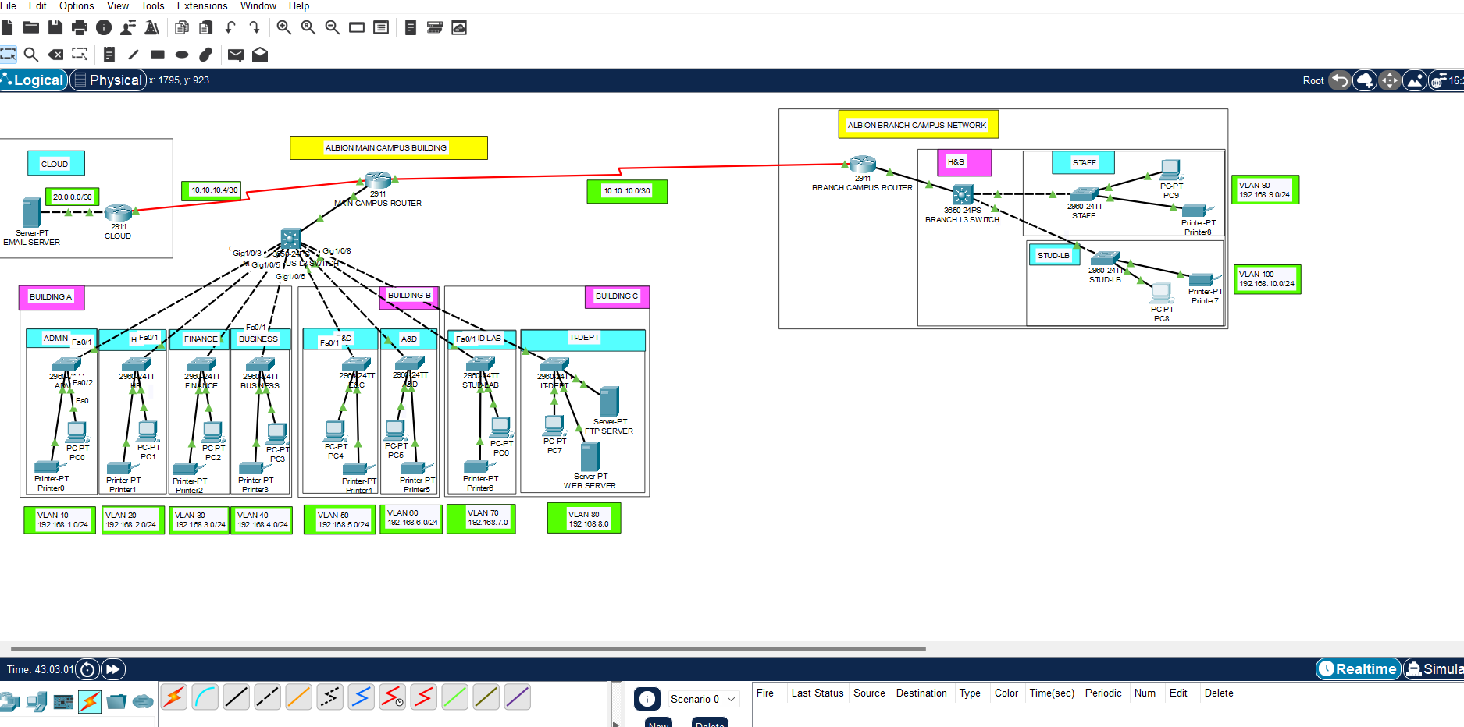

**CONFIGURATIONS:**

**ROUTER CONFIGURATIONS:**

1. **MAIN-CAMPUS ROUTER:**

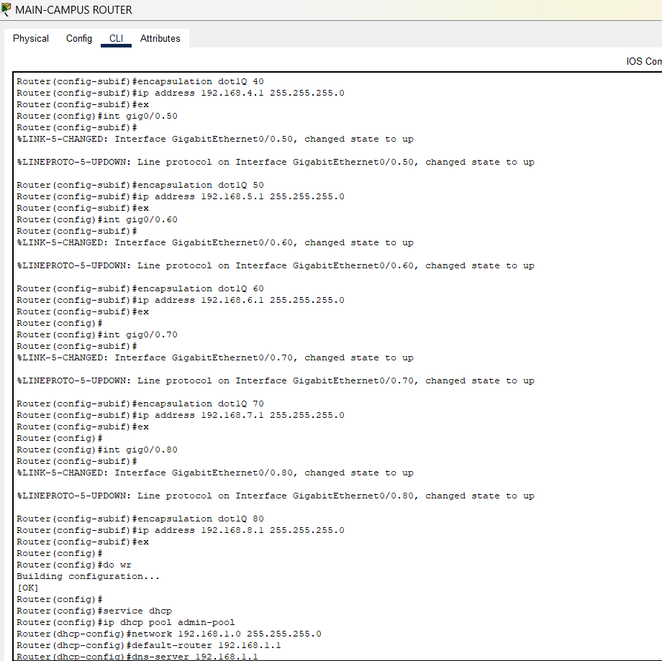

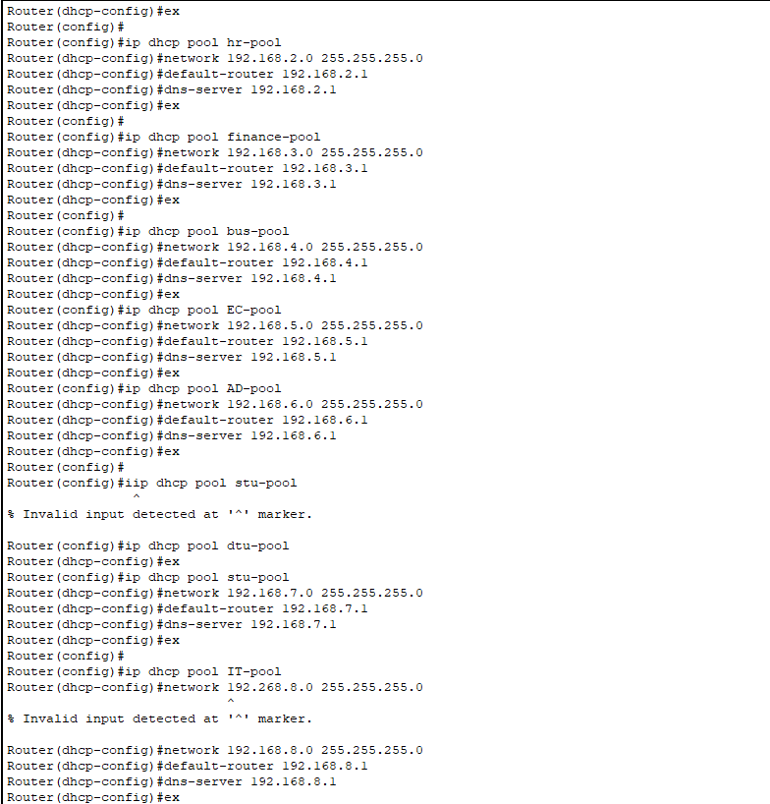

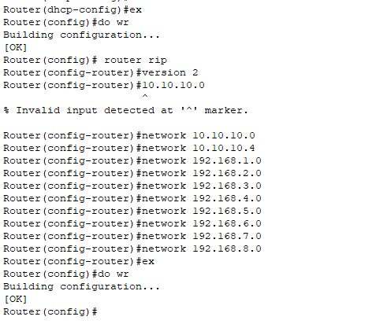

1. **BRANCH-CAMPUS ROUTER:**

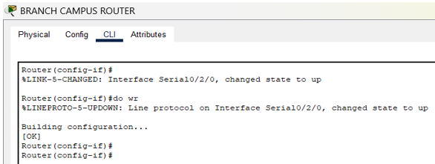

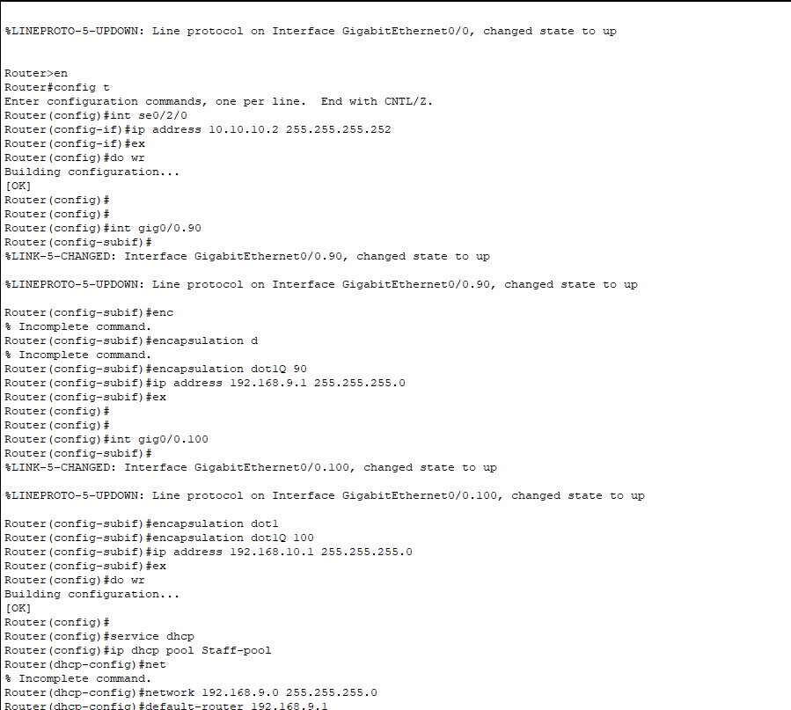

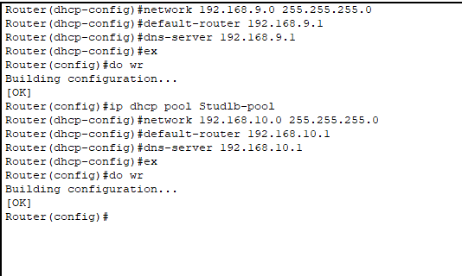

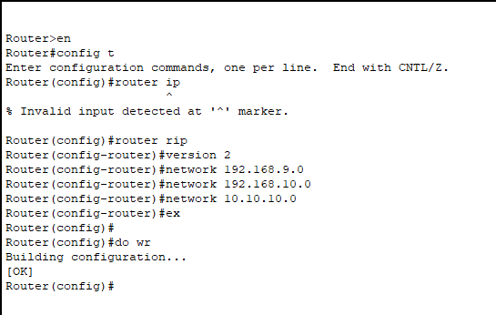

1. **CLOUD ROUTER:**

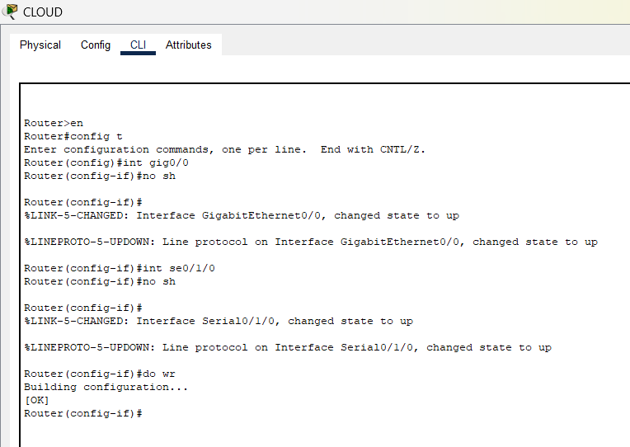

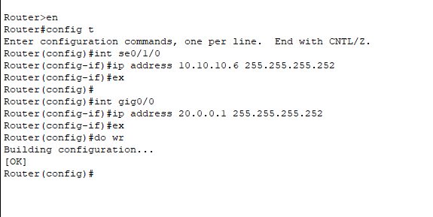

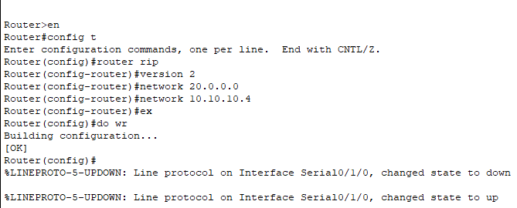

**SWITCHES CONFIGURATIONS:**

1. **MAIN-CAMPUS L3 SWITCH:**

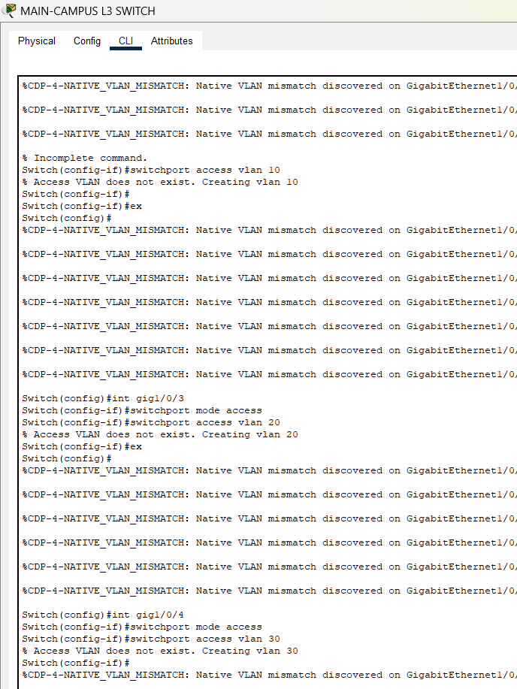

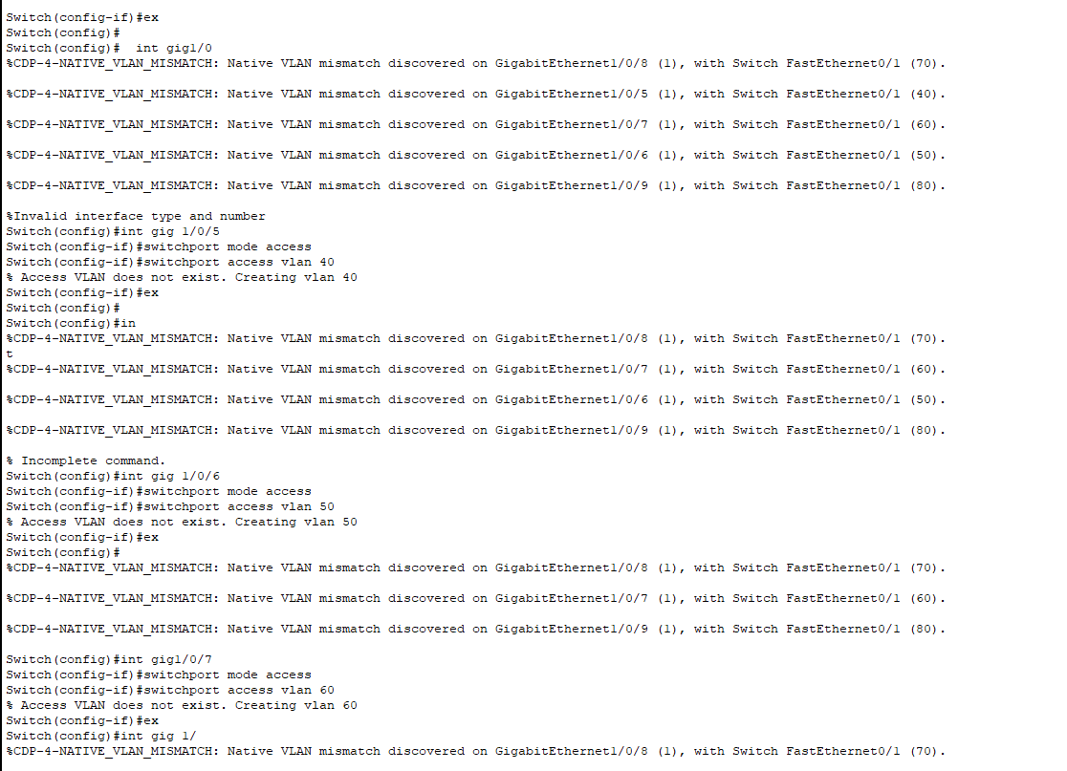

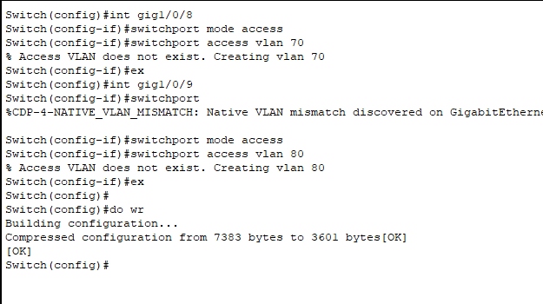

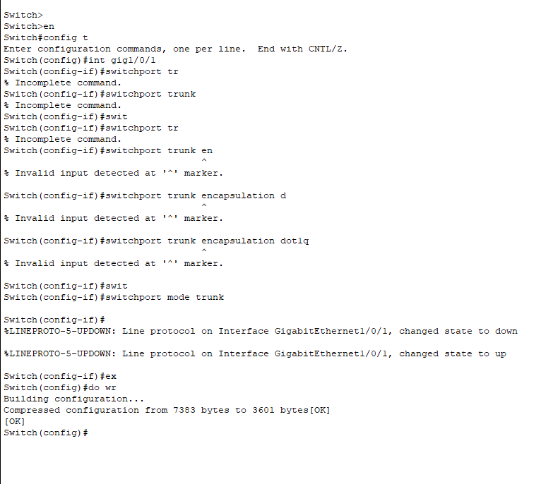

1. **BRANCH L3 SWITCH:**

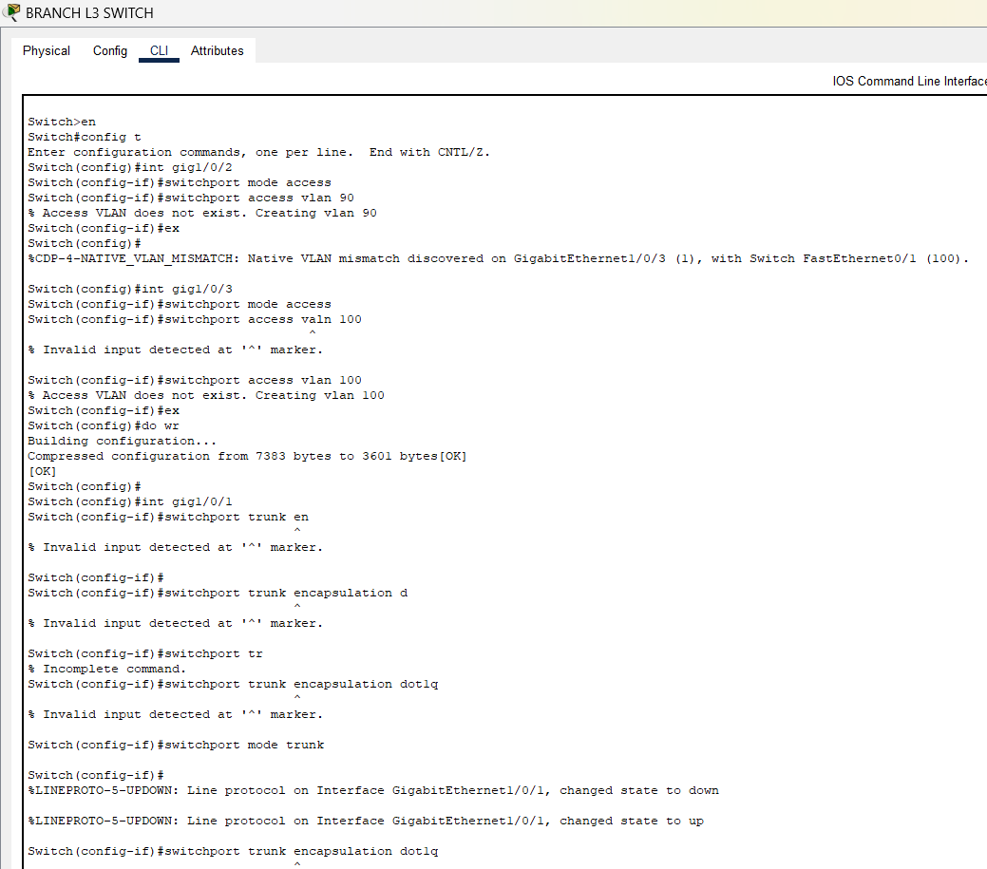

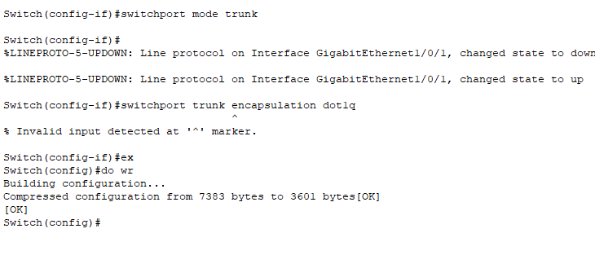

**SERVERS CONFIGURATIONS:**

1. **EMAIL SERVER:**

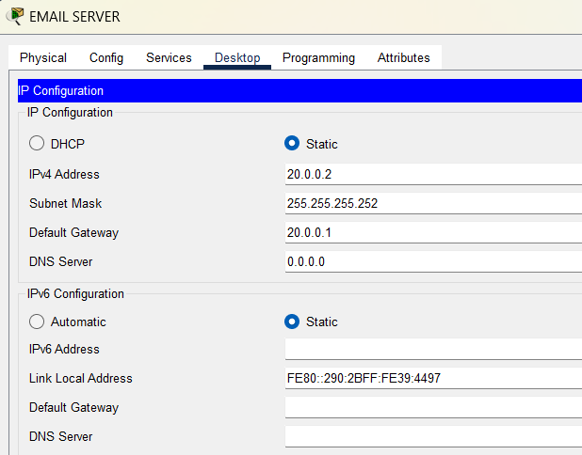

1. **WEB SERVER:**

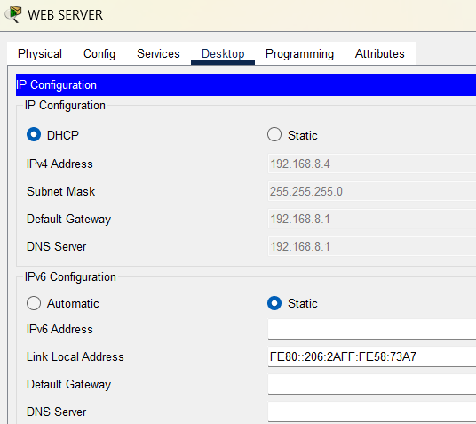

1. **FTP SERVER:**

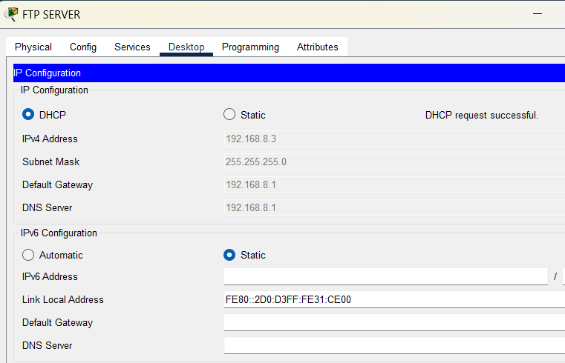

**RESULTS:**

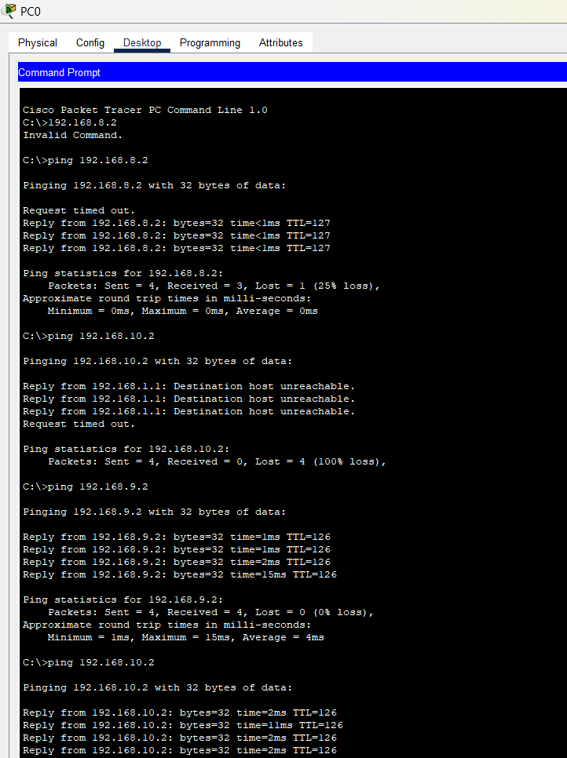

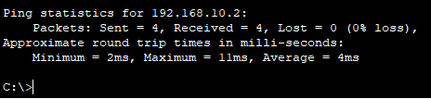

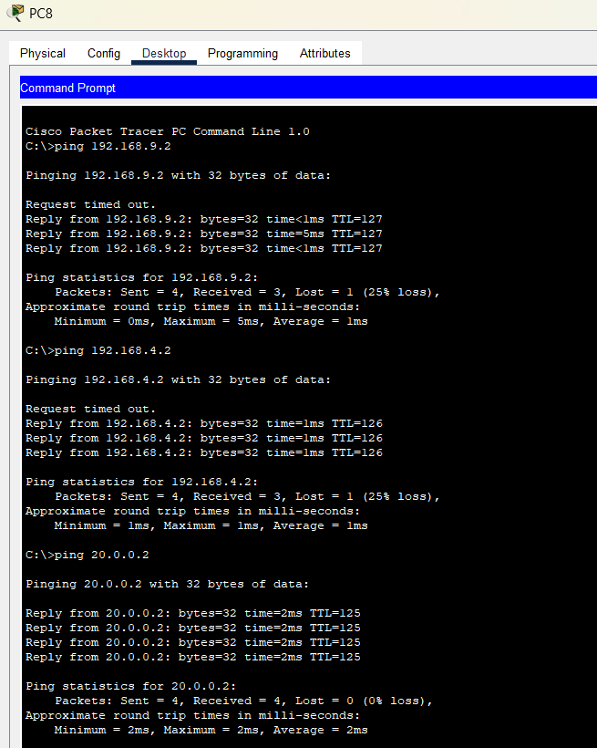

**CONCLUSION:**

The successful implementation of Albion University’s network topology demonstrates a functional and scalable solution. Key achievements include:

* Segmented network using VLANs for efficient traffic management and security.
* Reliable dynamic IP addressing with the DHCP server in Building A.
* Seamless connectivity across the main and smaller campuses through RIPv2 routing.
* External server access using static routing.

This network is now equipped to handle current and future requirements, ensuring robust connectivity and optimized resource utilization.

**SOFTWARE TOOL:**

Cisco Packet Tracer

**REFERENCES:**

* "Packet Tracer Network Simulator" by Cisco Networking Academy
* “Gurutech Networking Training” Youtube channel

**GITHUB LINK:**

*https://github.com/Kinza-Anwar/CampusNetwork*